

project report

comparison learning vector quantization and naïve bayes algorithm in airline passenger satisfaction

NIKODEMUS GALIH CANDRA WICAKSONO

18.K1.0082

Faculty of Computer Science

Soegijapranata Catholic University

2020

APPROVAL AND RATIFICATION PAGE (Heading plain)

(gunakan style “Approval”)

JUDUL PROJECT ANDA

by

NIKODEMUS GALIH CANDRA WICAKSONO – 18.K1.0082

This project report has been approved and ratified

By the Faculty of Computer Science on January, DD. YYYY

With approval,

|  |  |
| --- | --- |
|  | Supervisor  Dosen Pembimbing Project  NPP: ­ |
| Examiners,  1.)  [NAMA PENGUJI 1]  NPP :  2.)  [NAMA PENGUJI 2]  NPP :  3.)  [NAMA PENGUJI 3]  NPP : |  |
|  | Dean of Faculty of Computer Science  Robertus Setiawan AJi Nugroho, Ph.D  NPP: 058.1.2004.264 |

DECLARATION OF AUTHORSHIP

I, the undersigned:

Name : NIKODEMUS GALIH CANDRA WICAKSONO

ID : 18.K1.0082

declare that this work, titled "JUDUL ANDA", and the work presented in it is my own. I confirm that:

1. This work was done wholly or mainly while in candidature for a research degree at Soegijapranata Catholic University
2. Where any part of this thesis has previously been submitted for a degree or any other qualification at this University or any other institution, this has been clearly stated.
3. Where I have consulted the published work of others, this is always clearly attributed.
4. Where I have quoted from the work of others, the source is always given.
5. Except for such quotations, this work is entirely my own work.
6. I have acknowledged all main sources of help.
7. Where the work is based on work done by myself jointly with others, I have made clear exactly what was done by others and what I have contributed myself.

Semarang, MONTH, DD, YYYY

[sign here]

NIKODEMUS GALIH CANDRA WICAKSONO

18.K1.0082

ACKNOWLEDGMENT

Silahkan tuliskan anda ingin mengucapkan terima kasih atau ucapan persembahan ke siapapun yang anda rasa perlu ditulis disini

I have received a myriad of support, advice, and assistance throughout this document writing. I would like to thank my supervisors XXXXXX for formulating this topic. I would also like to thank my friend XXXXX for guiding with advice to finish this document.

I would like to thank my family and friends for giving me ceaseless love, support, and advices throughout my study in Soegijapranata Catholic University. You gave me great escape to rest my mind from my thesis.

ABSTRACT (Abstract Title)

Isi dari abstract menggunakan syle abstract content. Abstract ditulis dalam 3 paragraf. Semua ditulis dengan huruf italic dan 1 spasi Paragraf pertama berisi tentang permasalahan yang diselesaikan dalam project ini.

Paragraf kedua di sini, membahas tentang proses penyelesaian yang Anda tawarkan.

Sedangkan paragraf ketiga membahas tentang hasil akhir. Setelah itu di bagian paling bawah, sertakan keywords atau kata kunci 3-5 kata.

Keyword: kata_kunci1, kata_kunci2, kata_kunci3, dst

*Tambahkan informasi mengenai penelitian payung di sini apabila ada (konsultasikan dengan dosen pembimbing).

TABLE OF CONTENTS

COVER i

APPROVAL AND RATIFICATION PAGE (Heading plain) ii

DECLARATION OF AUTHORSHIP ii

ACKNOWLEDGMENT ii

ABSTRACT (Abstract Title) ii

TABLE OF CONTENTS ii

LIST OF FIGURE ii

LIST OF TABLE ii

CHAPTER 1 PETUNJUK PENULISAN (Style: Heading 1) 2

1.1. Petunjuk Penggunaan Template (Style: Heading 2) 2

1.1.1. Bagian sub-subchapter 2

1.1.2. Penulisan bilangan dan satuan 2

1.1.3. Penomoran halaman 2

1.1.4. Penomoran judul gambar dan judul tabel 2

1.1.5. Penomoran formula dan fungsi matematika 2

1.2. Isi Laporan Akhir 2

CHAPTER 2 INTRODUCTION 2

2.1. Background 2

2.2. Problem Formulation 2

2.3. Scope 2

2.4. Objective 2

CHAPTER 3 LITERATURE STUDY 2

CHAPTER 4 RESEARCH METHODOLOGY 2

CHAPTER 5 ANALYSIS AND DESIGN 2

5.1. Analysis 2

5.2. Penambahan Gambar, Judul Gambar, dan Penggunaan Gambar 2

5.3. Tabel, Posisi, dan Isi tabel 2

5.4. Desain 2

5.5. Function 2

CHAPTER 6 IMPLEMENTATION AND TESTING 2

6.1. Implementation 2

6.2. Testing **Error! Bookmark not defined.**

CHAPTER 7 CONCLUSION 2

REFERENCES 2

APPENDIX b

LIST OF FIGURE

**Figure 5.1** Diagram Analisis Masalah (Figure Caption) 2

**Figure 5.2** (a) Model DCGAN [9] dan (b) Model VAE [10] 2

**Figure 5.1** Contoh equation 2

**Figure 5.2** Penambahan angka untuk equation 2

**Figure 5.3** Equation setelah ditambahkan angka 2

LIST OF TABLE

**Table 5.1.** Tabel Analisis Data (Table caption) 2

# 1

# INTRODUCTION

## Background

Passenger satisfaction is one of the important factors for the improvement of an airline. The airline can find out what things need to be improved. With the hope that more and more airplane passengers use the airline, of course this increase must be done so that income also increases. To improve service, of course, you must know what things make passengers satisfied. This can be done from the data of passengers who have traveled by plane.

In this digital era, data is very easy to store and obtain. Not like in the past, which used paper to record data, but used the help of computers. One of the advantages is that it is easy to store large amounts of data, including passenger satisfaction data. If there are about 130,000 airline passenger satisfaction data, of course it is very difficult to process manually. This will make it difficult for airlines to improve services.

Because data storage uses a computer, we can also use a computer to process it. However, to process the existing data in order to get the results we want, an algorithm is needed. With the algorithm implemented on passenger satisfaction data, we can classify things that can make passengers satisfied with airline flight services. Of course, this is better than processing thousands of data manually.

Therefore, this time I implemented the Learning Vector Quantization (LVQ) and Naïve Bayes algorithms on the airline passenger satisfaction data that I got through Kaggle. It is hoped that this algorithm can process thousands of existing data and classify them. I am using 2 different algorithms so that I can compare the results of each implemented algorithm. And also, to find out which algorithm is better for classifying airline passenger satisfaction data by comparing the accuracy of the two algorithms. The results of this classification algorithm are expected to help airlines know what to do in the future.

## Problem Formulation

From the background above, we can formulate the existing problems.

1. Can the Naïve Bayes algorithm classify airline passenger satisfaction data?
2. Can the Learning Vector Quantization algorithm classify airline passenger satisfaction data?
3. Based on the level of accuracy, which algorithm is better in classifying passenger satisfaction data?

## Scope

In this project, I implemented Learning vector quantization and Naive Bayes algorithms only for the data I used from https://www.kaggle.com/binaryjoker/airline-passenger-satisfaction. And also, to find out a better algorithm, I use the accuracy parameter of each algorithm.

## Objective

The purpose of this project is to find out whether the Learning Vector Quantization and Naive Bayes algorithms can classify aircraft passenger satisfaction from existing data. In addition, to find out from the two implemented algorithms, which algorithm is better based on the level of accuracy.

# LITERATURE STUDY

Gorzalczany et al. [1] explain that a lot of data mining does not provide deeper explanations and justifications than decisions. Therefore, they apply their knowledge discovery technique based on fuzzy rules to the problem of airline passenger satisfaction. They used a dataset from Kaggle of 259,760 records. With 23 variable columns, the dataset is almost the same as the dataset that I will use. The results obtained are that the most significant attribute is Inflight Entertainment with an accuracy of 75.2%. Followed by the attributes of Seat comfort and Inflight Wi-Fi Service. They do not classify, but can determine which classification variables affect airline passenger satisfaction more.

With the US Airlines dataset which is almost the same as before, Hayadi et al. [2] uses several classification algorithms. The algorithms used are KNN, Logistic regression, Gaussian NB, Decision Trees and Random Forest. The author runs using the GridSearchCV algorithm from Scikit-Learn. Of all the algorithms that have been run, Random forest has the best performance with 99% accuracy, 97% precision and 94% recall. From the many simulations carried out, the authors suggest optimizing the in-flight wi-fi service. After that also simplicity about online booking. Unlike before, this time with around 130,000 data that becomes 70,000 after deleting the NaN (Not a Number) value, it doesn't include inflight entertainment as an attribute that needs to be improved.

Different from the previous ones, but still about airline customer satisfaction. Hanif et al. [3] uses a dataset of 152 respondents who have used one of the Indonesian airlines, namely Lion Air. The data is taken and grouped by occupation so that it becomes 100 data and 5 classes of work. The author uses the SPSS tool to get the conclusions. By looking for multiple regression, validity, reliability, T test, F value test and the coefficient of determination and correlation, it is found that there is a positive and significant influence between service quality, passenger satisfaction and passenger behavioral intentions. The disadvantage of this research is that the data used is too little so that it can get different results if there are more datasets.

In the journal written by Wijayanto et al. [4], the Naive Bayes algorithm is also used for the passenger satisfaction dataset taken from Kaggle. The dataset used is most likely the same as that which will be used from this journal. With 129,880 data, the author uses the help of the KNime application for classification with Naive Bayes. The distribution of training data and data testing consists of 4 experiments. The first is training data: testing data is 90:10, the second is 85:15, the third is 80:20 and the last is 75:25. The results obtained that 90% of training data and 10% of testing data have an accuracy of 81.466%.

Religia and Amali [5] also uses Naive Bayes to classify airline passenger satisfaction. The dataset used is also from Kaggle but is different, as many as 25,976 data. In their research, they used Naive Bayes, Naive Bayes optimized particle swarm Optimization (PSO) and finally Naive Bayes optimized Genetic Algorithm (GA). To measure the performance used accuracy, precision and recall. The results obtained are that Naive Bayes optimized by PSO has the best results, namely the accuracy value is 86.13%, the precision value is 87.9% and the recall value is 87.29%.

Similar to this journal, Nugraha et al. [6] compare Naive Bayes with Learning Vector Quantization (LVQ) to classify. But here it is used to classify uterine diseases. In using Naive Bayes, the author uses 2 methods, Naive Bayes by using Laplacian Smoothing and without using it. The data used are 125 data from the medical records of patients at RSUD Dr. Moewardi Solo. The data here is divided into 4 experiments/simulations with the first experiment being training: the data is 20:80, the second is 40:60, the third is 60:40 and the last is 80:20. The results of 4 trials with training 20%, 40%, 60%, 80% got Naive Bayes without Laplacian Smoothing had 32%, 67.8%, 79%, 88.8% accuracy. These results are less good than if Naive Bayes using Laplician smoothing has an accuracy of 88%, 92.4%, 92.8%, 92.4%. The accuracy is said to be stable even though the training data is changed. Compared to LVQ the accuracy is 82.4%, 88.8%, 89.4%, 95.2%. However, the highest accuracy is obtained from LVQ with 80% training.

In another journal, for LVQ signature pattern recognition compared by Prabowo et al. [7] and combined by Ginting et al. [8]. Prabowo et al. compared with the Kohonen Neural Network (KNN), while Ginting et al. combined with Self Organizing Kohonen (SOK).

In the journal Prabowo et al. did 3 tests. Each test with a different number of classes, resolutions and patterns. In the first test with 25 patterns and a resolution of 30x20 Kohonen had 96% success for 1 second while LVQ was 100% for 2 seconds. Second with 40 patterns and 30x20 resolution with 95% Kohonen less than 1 second while LVQ 92.5% less than 1 second. The last test was 9 patterns with 100x100 resolution with 77.78% Kohonen for 2 seconds and LVQ 88.89% for 7 seconds. LVQ does have better accuracy than Kohonen, but it takes longer. While in the journal Ginting et al. can speed up the computational process. The combination of LVQ with SOK increases the processing speed of computing during training or during signature pattern recognition.

Unlike previous comparisons or combinations, Meliawati et al. [9] implement LVQ to predict majors at SMA PGRI 1 Banjarbaru. The data used is obtained from the value of report cards in 2010, 2011 and 2013. The data is used as training data, while the value of report cards in 2014 is used as testing data. It is not known how much of the exact amount of data was used. Researchers get 79.31% accuracy for iterations 60 and 90.

Samsir [10] also implements LVQ. LVQ is used to classify Throat Nose and Ear (ENT) disease at Rantauprapat Hospital Labuhanbatu. The input variable consists of 10 disease symptoms. The dataset used is small, which is only 57 data. Of the 57 data divided into 4 training. With the comparison of training data: Testing data is 60:40, second 70:30, third 80:20 and 90:10. In the results of testing accuracy, it is not found that the more testing data, the accuracy will improve. Maybe it's because there are too few datasets, so you might get different results if you get more datasets.

From the journal Gorzalczany et al. [1] and Hayadi et al. [2], the dataset used is almost the same. But both use different algorithms in classifying them. While Hanif et al. [3] using very different datasets and different algorithms, but it's still about passenger satisfaction. However, Wijayanto et al. [4] using the same dataset and algorithm, namely Naive Bayes only, but not compared to LVQ. Likewise, Religia and Amali [5] use only Naive Bayes to classify airline passenger satisfaction, but the datasets used are different. In the journal Nugraha et al. [6] The algorithms both compare LVQ and Naive Bayes, but they use it to classify obstetrical diseases. Prabowo et al. [7] also compared LVQ but with KNN for the case of signature pattern recognition. While Ginting et al. [8] combines LVQ with SOK for signature pattern recognition cases as well. For Meliawati et al. [9] and Samsir [10], they only implement LVQ with different datasets without comparing them or combining them.

# RESEARCH METHODOLOGY

## Data Collection

In collecting datasets, I use websites that provide various kinds of datasets. For this research I used data from https://www.kaggle.com/binaryjoker/airline-passenger-satisfaction. Data with the file name airline_passengeer_satisfaction.csv has a file size of 14.34MB. I downloaded this data on September 20, 2021. To download it you are required to Sign In first (Register if you don't have an account). The downloaded file will be a zip file, so it must be extracted to get the csv file. The total data obtained were 129,880 with 23 measuring columns and 1 response column.

## Algorithm

In choosing the algorithm, I consulted my supervisor. During the consultation, my lecturer informed and suggested the Learning Vector Quantization (LVQ) algorithm. This algorithm has not been used very often. Therefore, I use this LVQ algorithm. After using LVQ I looked for another algorithm to use as a comparison. Then I chose Naive Bayes because this algorithm is an algorithm that is often used, easy and has good accuracy. I use these two algorithms to classify supervised learning data about airline passenger satisfaction that has been obtained previously. In addition to knowing which algorithm is better in accuracy.

## Coding and Design

In this step, the MySql tools will be used. MySql is used because the existing dataset is in the form of 2-dimensional data (columns and rows) the same as the MySql database table. In addition, the installation of Mysql is very easy. By downloading xampp through the website https://www.apachefriends.org/download.html. Xampp already provides several versions for Windows, Linux and OS X operating systems. Here I use Linux. After MySql is installed, the data will be preprocessed. Continuous data such as age and distance will be changed first to make it easier to classify.

## Analysis

In analyzing, I will do 5 tests as follows :

Analysis

|  |  |  |
| --- | --- | --- |
|  | Training Data | Testing Data |
| I | 10% | 90% |
| II | 25% | 75% |
| III | 50% | 50% |
| IV | 75% | 25% |
| V | 90% | 10% |

In this analysis, it is divided into 5 stages to determine whether the amount of training has an effect. Influence on Naive Bayes accuracy and on LVQ accuracy.

## Make a Report

In making the report, I wrote chapters 1-4 first. After chapter 4 finished, I started the coding stage for program development. Then the results that have been carried out during the coding stage will be recorded in the chapter 5 report. And finally, conclusions will be drawn from the results of the coding stage which will be written in chapter 6.

# ANALYSIS AND DESIGN

## Analysis

Bab ini memberikan penjelasan tentang metode penyelesaian masalah. Jabarkan metode analisis dan metode yang anda gunakan untuk menyelesaikan permasalahan yang disajikan disajikan dalam bentuk yang rinci, bisa dalam bentuk narasi tapi bisa juga dalam bentuk diagram gambar. Penomoran diagram maupun tabel mengikuti penomoran chapter.

## Penambahan Gambar, Judul Gambar, dan Penggunaan Gambar

Jika menggunakan diagram, letakkan di tengah dan gunakan fasilitas caption dari Libreoffice untuk memberikan keterangan gambar tersebut di bagian bawah gambar.

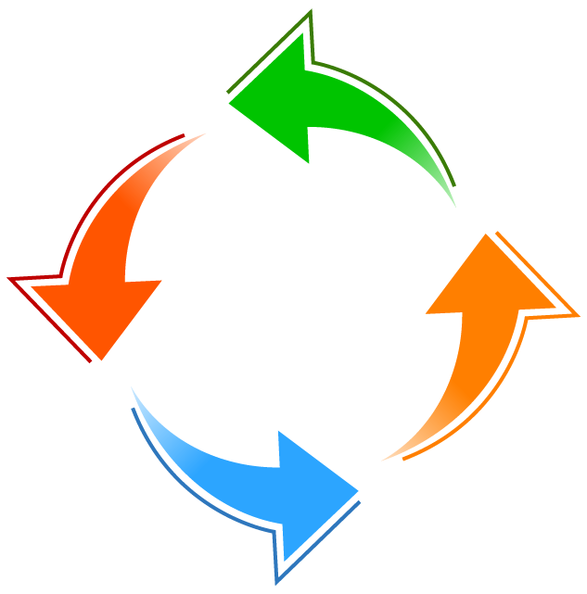

Diagram Analisis Masalah (Figure Caption)

Gambar menggunakan mode “in line text”. Dibawah gambar harus diberikan judul gambar yang berisi nomor gambar dan judul dari gambar yang ditampilkan. Untuk mempermudah dan menyeragamkan antar artikel, gunakan style “Figure” dan diikuti dengan judul gambar.

Judul gambar ditulis menggunakan huruf kapital untuk setiap kata, menyesuaikan dengan tata cara penulisan judul Bahasa Inggris. Judul gambar menggunakan style “Caption Figure” yang ditempatkan di bawah dari gambar.

Setiap gambar harus dibahas dalam bentuk tulisan dan digunakan sebagai referensi. Sebagai contoh, model pada Figure 5.2, adalah model generatif untuk teks yang akan diperbincangkan lebih dalam dalam penelitian ini [11].

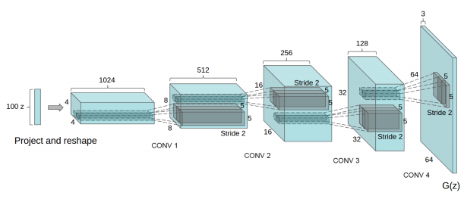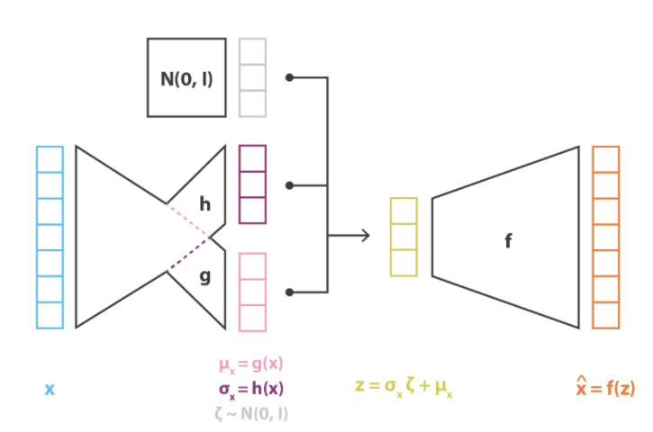

**(a)**

(b)

(a)

(a) Model DCGAN [12] dan (b) Model VAE [13]

Dalam satu baris hanya diperkenankan 1 buah judul gambar (tidak boleh ada 2 judul gambar yang tampil berurutan). Dalam kasus anda perlu menampilkan beberapa gambar secara beruntutan, sebaiknya jadikan beberapa gambar tersebut menjadi satu dan berikan keterangan pada judul gambar serta berikan border warna hitam untuk memisahkan antara gambar satu dengan lainnya. Sebagai contoh pada Figure 5.2Figure 5.2(a) adalah model *generative adversarial network* yang merupakan model generatif yang mampu menghasilkan gambar yang realistis [14], sedangkan pada Figure 5.2(b) adalah model generatif yang mendasarkan pada model autoencoder yang dinamakan *variational autoencoder* [15]. Dalam hal gambar yang terlalu banyak atau terlalu kecil jika digabung dan tidak memungkinkan ditampilkan pada satu baris disarankan untuk memisah gambar tersebut kedalam beberapa judul gambar dengan catatan tidak boleh ada 2 gambar dengan judulnya masing-masing yang tampil berurutan dengan cara memisahkan 2 gambar tersebut dengan sebuah paragraf (atau beberapa paragraf) yang menjelaskan gambar yang pertama, baru diikuti oleh gambar yang kedua kemudian diikuti oleh penjelasan gambar kedua. Figure 5.2 adalah contoh 2 buah gambar yang digabung namun terlalu kecil sehingga tulisan-tulisan di dalamnya tidak terlihat. Contoh ini disediakan agar anda tidak melakukan kesalahan serupa.

Dalam penggunaan gambar, usahakan gambar tersebut dapat terlihat dengan jelas. Anda dapat merubah gambar dalam bentuk hitam putih untuk mengetahui apakah gambar tersebut dapat terlihat dengan jelas atau tidak. Minimalisir pula penggunaan foto.

## Tabel, Posisi, dan Isi tabel

Selain gambar, penyajian ilustrasi dalam bentuk data yang di tuangkan kedalam tabel juga dapat dilakukan. Tabel tidak diperkenankan untuk melebihi ukuran dari margin namun harus memenuhi seluruh lebar halaman dan caption bagian atas diletakkan di tengah. Spasi untuk tabel adalah 1 spasi. Jika tabel terlalu besar maka pisahkan data nya atau kurangi data yang ada pada tabel tanpa mengurangi informasi yang perlu diketahui oleh pembaca.

Tabel Analisis Data (Table caption)

|  |  |  |  |
| --- | --- | --- | --- |
| Table Head | Table Column Head | | |
| Table SubHead | Table SubHead | Table SubHead |
| No | Table content | Table content | Table content |

Sama seperti gambar, tabel juga harus dinarasikan pada tulisan laporan anda seperti pada paragraf ini. Pada Table 5.1, dijabarkan dalam bentuk contoh, isian yang mungkin untuk dituliskan dalam sebuah tabel. Masing-masing bagian dari isi tabel memiliki style yang sudah didefinisikan sebelumnya. Sebagai contoh jika anda ingin menulis bagian head silahkan gunakan style “Table Head” atau “Table Column Head” sesuai kebutuhan anda.

## Desain

Bahas desain yang Anda tawarkan sebagai solusi dari masalah yang ingin diselesaikan. Desain yang ditawarkan dapat berupa gambar diagram seperti use case, DFD, DAD, dan lain-lain yang disesuaikan dengan kebutuhan.

Dari berbagai pembahasan laporan project, mungkin saja Anda mengambil kutipan dari sumber lain, maka dituliskan sebagai catatan kaki atau footnote[1] atau sebagai sitasi.

Khusus laporan project yang menyertakan gambar, diagram dan lain sebagainya, harus dinarasikan sehingga memudahkan pembaca memahami gambar yang Anda sertakan dalam laporan seperti contoh yang diberikan pada subchapter 5.2.

## Function

Fungsi adalah ilustrasi matematis yang dituliskan dalam bentuk rumus-rumus. Anda tidak diperbolehkan menggunakan gambar sebagai rumus, sebaiknya gunakan equation editor dan gunakan command yang tersedia, untuk lebih jelasnya silahkan lihat pada tutorial penggunaan equation editor[2]. Rumus tersebut ditulis di tengah dan diberi nomor di sebelah kanan. Selain itu rumus juga harus dijelaskan terutama notasi-notasi yang terdapat pada rumus yang bersangkutan secara langsung dan dinarasikan dalam bentuk kalimat yang berisi penjelasan kegunaan atau sifat dari rumus tersebut.

$$\begin{aligned}N\left(0,1\right)≈\frac{1}{σ\sqrt{2π}}ⅇ^{-\frac{1}{2}{\left(\frac{x-μ}{σ}\right)}^{2}} \#\left( SEQ Equation \backslash * ARABIC 1\right)\end{aligned}$$

Pada fungsi (1), $N$ adalah notasi distribusi normal, $σ$ adalah standar deviasi, $μ$ adalah rata-rata aritmetik, dan $ⅇ$ adalah bilangan natural. Keseluruhan fungsi (1) menjelaskan perhitungan *Gaussian bell* [16].

Untuk dapat menuliskan fungsi dengan penomoran otomatis berikut adalah cara untuk mempermudahnya. Pertama-tama tuliskan fungsi anda seperti biasa, kemudian di akhir fungsi anda tambahkan spasi, namun pastikan masih di dalam kotak equation dan kemudian tambahkan tanda “#()” seperti pada Figure 5.1.

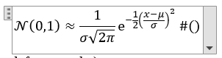

Contoh equation

Kemudian arahkan cursor anda diantara tanda kurung buka dan kurung tutup “()” dan klik insert caption, pilih caption untuk equation dan pastikan “Exclude label from caption” sudah tercentang seperti pada Figure 5.1. Setelah itu klik OK.

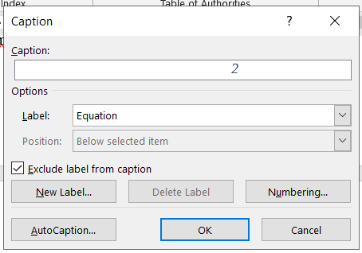

Penambahan angka untuk equation

Kemudian angka akan muncul otomatis seperti pada Figure 5.3.

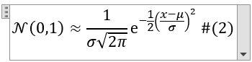

Equation setelah ditambahkan angka

Kemudian arahkan cursor anda di akhir dari tanda kurung tutup “)” dan tekan enter, maka equation anda akan berubah menjadi seperti fungsi dibawah,

$$\begin{aligned}N\left(0,1\right)≈\frac{1}{σ\sqrt{2π}}ⅇ^{-\frac{1}{2}{\left(\frac{x-μ}{σ}\right)}^{2}} \#\left( SEQ Equation \backslash * ARABIC 2\right)\end{aligned}$$

# IMPLEMENTATION AND RESULTS

## Implementation

Bab implementasi adalah bab tentang narasi pemanfaatan dari data structure dan algoritma dalam bentuk aplikasi terapan.

Bab implementasi menyertakan source code, namun tidak semua source code program disertakan dalam bab ini. Ambil lah penggalan nya saja yang penting dan menjadi inti dari program Anda. Gunakan style “Code” . Jika menyertakan gambar (capture), silahkan ditambahkan caption di gambar tersebut sebagaimana penjelasan pada Chapter 5.

1. create Function sfHelloWorld (vNama varchar(30))
2. returns varchar(100)
3. begin
4. declare vHello varchar(255)
5. select concat(‘Hello ‘, vNama) into vHello;
6. return vHello;
7. End

Setiap source code diberikan nomor urut baris. Jelaskan baris perintah dan untuk apa perintah tersebut. Baris 1-2 kode program berisi perintah untuk membuat function dengan nama sfHelloWorld. Baris 3 dan 7 adalah blok baris untuk function khusus di dalamnya. Inti dari kode program ada pada baris 4 untuk deklarasi variabel vHello, baris 5 untuk menggabungkan karakter “Hello” dengan variabel vNama dan mengembalikan hasilnya pada baris ke 7.

## Results

Sub bab results berisi hasil dari uji coba algoritma dan struktur data yang diterapkan dalam bentuk aplikasi. Hasil disajikan dalam bentuk tabel, narasi atau gambar yang dapat memberikan penjelasan solusi masalah dengan bantuan program sehingga dapat ditarik kesimpulan dari penelitian anda.

# CONCLUSION

Bab ini membahas tentang kesimpulan akhir. Harus menjawab semua pertanyaan yang Anda ajukan sebagai permasalahan yang bab 1 bagian scope. Tidak sekedar menyimpulkan tapi sertakan argumentasi kuat terkait pengambilan kesimpulan tersebut.

Di bagian akhir, sertakan saran untuk penelitian lanjutan. Tidak perlu bertele-tele tapi fokuskan pada saran penelitian Anda saja, apa yang belum dilakukan disertakan di sini.

REFERENCES

[1] M. B. Gorzałczany, F. Rudziński, and J. Piekoszewski, “Business Intelligence in Airline Passenger Satisfaction Study—A Fuzzy-Genetic Approach with Optimized Interpretability-Accuracy Trade-Off,” *Applied Sciences*, vol. 11, no. 11, p. 5098, May 2021, doi: 10.3390/app11115098.

[2] B. H. Hayadi, J.-M. Kim, H. T. Sukmana, and K. Hulliyah, “Predicting Airline Passenger Satisfaction with Classification Algorithms,” *IJIIS : Int. J. Inform. Inform. Systems.*, vol. 4, no. 1, pp. 82–94, Mar. 2021, doi: 10.47738/ijiis.v4i1.80.

[3] M. R. Hanif, R. Chrizara, E. Saribanon, and I. Ozali, “THE EFFECT OF SERVICE QUALITY AND PASSENGER SATISFACTION ON PASSENGER BEHAVIORAL INTENTIONS ON LION AIR,” p. 9.

[4] A. Wijayanto, J. F. A. Bernardo, and S. Pamungkas, “Analisis Klasifikasi Kepuasan Penumpang Maskapai Penerbangan Menggunakan Algoritma Naïve Bayes,” *J-SAKTI*, vol. 3, no. 2, pp. 97–103, May 2021, doi: 10.33084/jsakti.v3i2.2041.

[5] Yoga Religia and A. Amali, “Perbandingan Optimasi Feature Selection pada Naïve Bayes untuk Klasifikasi Kepuasan Airline Passenger,” *RESTI*, vol. 5, no. 3, pp. 527–533, Jun. 2021, doi: 10.29207/resti.v5i3.3086.

[6] P. Aditya Nugroho, R. Saptono, and M. Eko Sulistyo, “Perbandingan Metode Probabilistik Naive Bayesian Classifier dan Jaringan Syaraf Tiruan Learning Vector Quantization dalam Kasus Klasifikasi Penyakit Kandungan,” *ITSmart*, vol. 2, no. 2, p. 21, Mar. 2016, doi: 10.20961/its.v2i2.628.

[7] A. Prabowo and E. A. Sarwoko, “Perbandingan Antara Metode Kohonen Neural Network dengan Metode Learning Vector Quantization Pada Pengenalan Pola Tandatangan,” vol. 14, p. 7.

[8] E. B. Ginting, Prof. Dr. M. Zarlis, and Dr. Z. Situmorang, “KOMBINASI ALGORITMA JARINGAN SYARAF TIRUAN LEARNING VECTOR QUANTIZATION (LVQ) DAN SELF ORGANIZING KOHONEN PADA KECEPATAN PENGENALAN POLA TANDA TANGAN.” 2014.

[9] R. Meliawati, O. Soesanto, and D. Kartini, “PENERAPAN METODE LEARNING VECTOR QUANTIZATION (LVQ) PADA PREDIKSI JURUSAN DI SMA PGRI 1 BANJARBARU,” vol. 04, p. 10, 2016.

[10] Samsir, “Klasifikasi Penyakit Tenggorokan Hidung Telinga (THT) Menggunakan Jaringan Syaraf Tiruan Dengan Metode Learning Vektor Quantization (THT) Di RSUD Rantauprapat Labuhanbatu.”

APPENDIX

Jika Anda punya lampiran dari project, silahkan dilampirkan di bagian ini. Yang wajib Anda lampirkan adalah kode program (coding) lengkap dan diberikan keterangan terlebih dahulu pada bagian atas dari coding tersebut, koding ditulis dengan format font yang berbeda. Contoh:

**CODING PEHITUNGAN**

1. SELECT @a := 5;
2. SELECT @b := 5;
3. SELECT hasil:= @a * @b;

**PROCEDURE HITUNG PERKALIAN**

1. CREATE PROCEDURE spMaksimal ()
2. BEGIN
3. DECLARE a INT;
4. DECLARE b INT;
5. DECLARE hasil INT;
6. SELECT a * b INTO hasil;
7. SELECT hasil
8. END

Selain coding, yang dapat dijadikan lampiran adalah: hasil hitungan yang panjang dan tidak mungkin dimuat dalam laporan utama, gambar atau ilustrasi diagram yang cukup panjang namun hanya sebagai penjelasan dari diagram utama yang ada di dalam laporan, foto-foto penunjang, dan dokumen lain yang sifatnya menunjang namun dianggap penting.

1. Jared Dean, Big Data, Data Mining, and Machine Learning. Value Creation for Business Leaders and Practitioners (New Jersey: John Wiley & Sons, Inc., 2014), hal. 5.
2. [Microsoft Word Equation Editor Tutorial (bgu.ac.il)](https://www.cs.bgu.ac.il/~khitron/Equation%20Editor.pdf)